/
Logistics Data

In order to better serve you and meet your schedule, this form must be completed and signed. Timely delivery and trouble-free installation begin with these survey forms. Please complete this Destination Based Dispatching form in addition to the iControl form. Non-response to a question is interpreted as meaning that the item does not apply.

Site & Contact Information
Date: | Number of cars:
Job name and address: (26 characters maximum per line)
__________________________________________

Owner Representative
Print Name: |  |  |  | Title:
Signature:
Business phone: |  |  | Cell phone:
Email:
Company name and address:

Job Location (city* and state):
Project Type: New construction Modernization
MCE to complete shaded area
Contract Date:
Customer Job #: |  |  | PO#:
Controller/Job Reference #
*For jobs located in NYC, see note below.
Contractor Information ( Check if same as above)
Contact:
Phone: |  | Fax:
Email:
Company name and address:

Consultant Info: ( Check if same as contractor)
Business Name:
Contact Name:
Business Phone:
Cell Phone:
Email:
Address:

Per state tax laws, it is critical that MCE receive exemption or resale certificates prior to the material being shipped and billed. If the job is tax-exempt, send the exemption certificate with this form. If you are a resale customer and have a resale certificate, please make sure that the MCE accounting department has a copy on file.

Form completed by: ( Check if same as contractor)
Name:
Business Phone:
Cell Phone:
Email:
Signature:

Critical Dates / Information
DBD Fixture Delivery Date
DBD Transition Date
Language: English Other

Shipping Information
Contact:
Phone: | Fax:
Company name and address:

Shipping Requirement:

Advanced Notice: 24 hours 48 hours
Truck w/ Lift Gate: Yes No

Please see our Destination Based Dispatching Catalog
We provide a brief description of our destination dispatching fixtures here to aid in making selections. For complete fixture descriptions, dimensions, and mounting information please ask for a copy of our catalog or download one from the MCE website at www.nidec-mce.com.

Help us define your system
In order to properly design your system, we need to know how many, and which floors will use destination dispatching, the location of elevators and input devices on those floors, and which fixtures you want to use. This form is designed to collect that information.
New York City Jobs:
As of May 2023, the NYC Building Code Chapter 11 Accessibility Requirements states all DIDs must have either a Step Scanner provision or numeric keypad input. MCE 7” (M73 page 13) and 10” (M14c page 9) Applied Mount with Step Scanner and CE (K1 and K2 page 16) with keypad are compliant with this requirement.

Security Overview
Security Overview
Security interfaces on Destination Dispatch jobs are different from the standard dry contact interfaces most installers are used to. The card readers normally inside the COP are placed next to each DID touch screen in the hallway. A relay type interface would require too many wires. Instead, DD jobs use a network interface to pass the card reader information to the access control company.

Security Type
No Security Required
Limited Discrete Security
Source Lockout Inputs – Single input into group per DID. If input is not active, then calls cannot be made from that DID. There is no way to control where the passenger goes, just if they can use the elevators. Every passenger will need an access card to use elevators (no guests or public floors from the secured source floors). This is normally needed for public floors such as unmanned lobby or parking floor in buildings that do not have standard security interfaces.
Destination Lockout Inputs – Single input per destination floor that when activated, will not allow any calls to that floor. Used for single tenant floor buildings when tenant wants to close down floors after they leave for the day. This option is simply a connection point for a hardware panel with keyed lockouts per floor.
Access Control Network Interface (Standard Card Reader Security)
MCE supports the following access control systems for office buildings. Selecting an access control manufacturer that is not in this list may mean extra costs to develop an interface from MCE and the Access Control Company. Please consult with your salesperson if your security company is not listed.
Direct Integration
Amag Symmetry | BluB0x | BraXos Steward | Computrols CBAS | CSI
DataWatch | Fortek | Genetec | ICT | IMRON
Kastle | Lenel OnGuard (v6.6, 7.1-7.5, 8.0) | Lift Net | RBH | Servas
SWH CCURE v2.7

Integration through BraXos Steward Platform (BraXos must be contracted through building or security company):
Honeywell ProWatch S2 Security NetBox
Siemens SiPass Hotel system such as Assa Abloy (Ving) or Kaba (SafLok)
Note: For additional information regarding Security Interface Requirements, refer to Sales Reference document P/N 42-SR-0016.
Card Reader Type
MCE can save hours of wiring by integrating the cardswipe into our data communications. This is only available with the HID 5127MINI reader and for the access control companies that support it.
MCE provided and premounted card readers:
* HID 5127 MINI (BluB0x & BraXos Only)
HID 6005 (Connects via Wiegand to Access company equipment)
HID R10/RP10 (Connects via Wiegand to Access company equipment)
HID SIGNO 20 (Connects via Wiegand to Access company equipment)
ICT PRX-TSEC-MINI-DF-B (Connects via Wiegand to Access company equipment)
ICT PRX-TSEC-MINI-BT-B (Bluetooth, connects via Wiegand to Access company equipment)
Separate customer provided and mounted card readers:
Card reader mounted NEXT to DID
Note: MCE can only mount readers provided by MCE.
*HID 5127 Card Reader requires 60mm rear clearance. Do not use with retrofit 7 inch or 10 inch DIDs (M11b or M71a), or with pedestals (M16 or M17).
Turnstiles
Floors in your Building
MCE provides an LCD screen and speaker that can be mounted at a turnstile to allow automatic call assignment while passing through the gate. Please make sure to select an Access Control Company on previous page.
Global Turnstile: Select if turnstile will access multiple elevator banks. (Only available for BluBox, BraXos, and Kastle.)
Custom Graphics
MCE offers the ability for the building to provide a custom background image on the DID Kiosk.
Image requirements:
10”: 1024 x 768 pixels 7”: 480 x 800 pixels
Note: For additional information regarding DID Screen Graphics, refer to Sales Reference document
P/N 42-SR-0019.
Note: Any Additional features (switches, indicators, engravings, etc.) must be external to the DID Kiosk and are not provided by MCE.

Floors in your Building – Planning Form
This form provides space to enter data for 8 cars, 54 floors, and 5 floor plans. If additional space is needed, please make copies of the form.
Following are instructions for filling out the form. Also refer to the “Example Form,” “Example Floor Plans” and supporting Tables on the following page.
- Under “Cars and Openings,” enter the “Labels” for the cars in this group, e.g., 1, 2, 3 or A, B, C, etc.
- Under “Voice Annunciator Message,” indicate the voice announcement to be used for each floor, e.g., 1st floor, floor 1, lobby floor, etc.
- Under “Floor Label,” indicate the floor label to be displayed on in-car fixtures (3 characters maximum).
- Under “Cars and Openings,” place an X in the boxes to indicate the openings for each car for each floor they serve.
- Under “DID Fixtures Type,” indicate the type of fixtures to be used (specified by the letter/number next to the fixtures listed below), and the quantity of fixtures to be used at each floor.
- Under “Other Fixtures Type,” indicate the type of fixtures to be used (specified by the letter/number next to the fixtures listed below), and the quantity of fixtures to be used at each floor.
- Under “Floor Plan,” indicate the number of the floor plan that illustrates the orientation of the cars, turnstiles (if applicable) and all destination fixtures on each floor.
  - Use the “Floor Plan” templates on page 6 to create the diagrams of the cars and location of the fixtures used by this group.

Example Form:
Floors in your Building
Floor Data |  |  | Cars and Openings |  |  |  |  |  |  |  |  |  |  |  |  |  |  |  | DID Fixtures Type |  |  | Other Fixtures Type
Lndg  # | Voice Annunciator  Message | Floor  Label | A  1 |  | B |  | C |  | D |  |  |  |  |  |  |  |  |  | M11a | M71 | C73 | H1 | H2 |  | Floor  Plan
 |  |  | F | R | F | R | F | R | F | R | F | R | F | R | F | R | F | R | Qty | Qty | Qty | Qty | Qty | Qty
5 | 3rd Floor | 3 |  |  |  |  |  |  |  |  |  |  |  |  |  |  |  |  |  | 1 |  | 0 | 3 |  | 4
4 | 2nd Floor | 2 |  |  |  |  |  |  |  |  |  |  |  |  |  |  |  |  |  | 2 |  | 0 | 5 |  | 3
3 | Lobby | L |  |  |  |  |  |  |  |  |  |  |  |  |  |  |  |  |  |  | 1 | 4 | 0 |  | 5
2 | Parking Garage 2 | P2 |  |  |  |  |  |  |  |  |  |  |  |  |  |  |  |  | 2 |  |  | 4 |  |  | 2
1 | Parking Garage 1 | P1 |  |  |  |  |  |  |  |  |  |  |  |  |  |  |  |  |  | 1 |  | 0 | 2 |  | 1

Example Floor Plans:
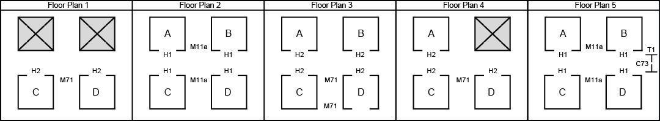

Destination Input Fixtures: DID fixtures include the following (Specify “Type” by the numbers in these lists):
MCE Touch Screen |  | CE Touch Screen |  | CE Keypad
M11a 10” Surface Mt RF no CR | *M17 10” Pedestal Standalone | C11 10” Surface Mt | C71 7” Surface Mt | K1 Surface Mt Flat
*M11b 10” Surface Mt RF + CR | *M71a 7” Surface Mt RF | C12 10” Applied Mt | C72 7” Applied Mt | K2 Surface Mt Angled
M11c 10” Surface Mt QR Scanner | M71b 7” Surface Mt NC | C13 10” Frameless | C73 7” Frameless
M12a 10” Surface Mt NC no CR | M71c 7” Surface Mt QR Scanner
M12b 10” Surface Mt NC + CR | M72a 7” Applied Mt
M13 10” Vertical Mt | M72b 7” Applied Mt QR Scanner
M14a 10” Applied Mt | M72c 7” Applied Mt Step Scanner
M14b 10” Applied Mt QR Scanner | M73 7” Frameless
M14C 10” Applied Mt Step Scanner
M15 10” Frameless no CR
*M16 10” Pedestal Against Wall
NOTE: Mt = Mount; RF = Retrofit; NC = New Construction; CR = Card Reader
Fixture Mount Fixtures M11, M12, M16, M17, and M71 meet California’s requirement of white text on black background on the ADA button.
*Do not use 5127 Card Reader with these configurations

Other Hall Fixtures: Destination / Annunciators
H1 LCD Destination/ Car Annunciator | H2 mBox/mLBox Annunciator w/Floor Gong | H4 Non-Serial Hall Fixture (DUPAR)
Messaging / Arrival PI | H3 mFlag w/ Floor Gong | (Contractor Supplied)

Door Jamb Fixtures
D1 4.3” LCD (no speaker) | D5 10 Line Segmented1/2” Display
D2 4.3” LCD (with speaker) | D6 10 Line Segmented 1” Display

Turnstile Fixtures
T1 7” LCD
T2 4.3” LCD

Floor Data |  |  | Cars and Openings |  |  |  |  |  |  |  |  |  |  |  |  |  |  |  |  | DID Fixtures Type |  |  | Other Fixtures Type
Lndg  # | Voice Annunciator  Message | Floor  Label |  |  |  |  |  |  |  |  |  |  |  |  |  |  |  |  |  |  |  |  |  |  |  | Floor  Plan
 |  |  | F | R | F | R | F | R | F | R | F | R | F | R |  | F | R | F | R | Qty | Qty | Qty | Qty | Qty | Qty
54
53
52
51
50
49
48
47
46
45
44
43
42
41
40
39
38
37
36
35
34
33
32
31
30
29
28
27
26
25
24
23
22
21
20
19
18
17
16
15
14
13
12
11
10
9
8
7
6
5
4
3
2
1
Spares:
Door Jamb Fixtures Type: Qty: Spares: Total: |  |  |  |  |  |  |  |  |  |  |  |  |  |  | Totals:

Floors in your Building
Floors in your Building
- Use the grids below to illustrate the layout of the building’s elevators and DBD fixtures.  - Use the fixture letter/numbers from page 4 to indicate the location of the fixtures.  - Indicate approximate distance from each DID to each elevator.  Note: If additional space is needed, pleased make copies of this form. | Example  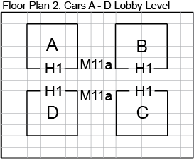

Floor Plan 1 | Floor Plan 2
Floor Plan 3 | Floor Plan 4

What fixtures are available?
Destination Input Devices
The fixtures that we offer include Destination Input Devices (DIDs), Per-Car Hall Fixtures, and In-Car Fixtures.

MCE Destination Input Devices
MCE’s destination entry touch screen fixtures are wall or kiosk mounted fixtures. Both the 10” and 7” models use capacitive multi-touch technology, similar to cell phones, with impact resistant glass, for long lasting and durable fixtures. Both models provide a physical, Braille selection switch in compliance with ADA requirements. Screen visual elements – background, control appearance
and messaging – may be customized if desired.
MCE Destination Input (DID) Fixtures
M11a 10” Surface Mount Retrofit, No Card Reader California Compliant
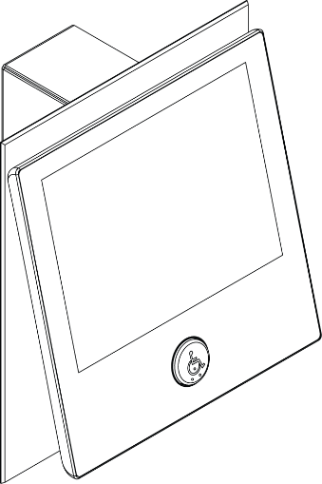 | 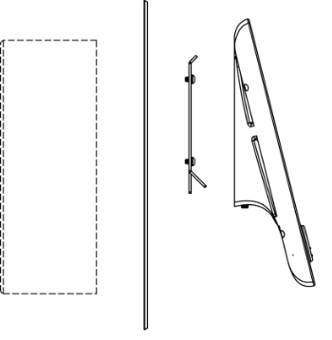  A  D  C  B  Existing Back Box shown. An optional Back Box can be ordered if required. | A: Optional Back Box Qty (3” W x 9 ¼” H x 3 ½” D)  B: Wall/Back Plate, (included, 1 per fixture)  Color / Finish:  Stainless #4*  Stainless #8  Muntz #4  Muntz #8  Black  White  C: Mounting Bracket (included 1 per fixture)  D: DID Fixture - Glass & Enclosure:  Black Qty  White** Qty
M11b 10” Surface Mount Retrofit, With Card Reader (except 5127 Card Reader) California Compliant
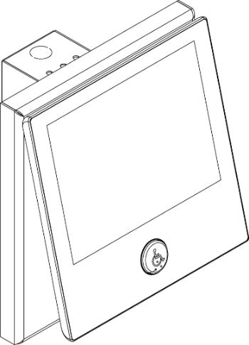 | 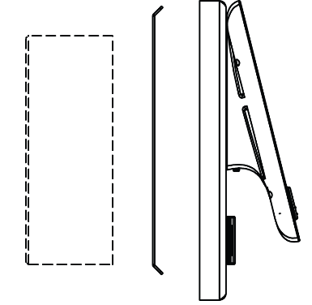  D  C  B  A  Existing Back Box shown. An optional Back Box can be ordered if required. | A: Optional Back Box Qty  (3” W x 9 ¼” H x 3 ½” D)  B: Mounting Bracket (included, 1 per fixture)  C: Fixture base¹  Color / Finish:  Stainless #4*  Muntz #4  Black  White  ¹Size based on security card reader selected  D: DID Fixture - Glass & Enclosure  Black Qty  White** Qty
M11c 10” Surface Mount QR Scanner California Compliant
 | C  A  D  B | A: Back Box (included, 1 per fixture)  B: QR Scanner (included, 1 per fixture)  C: Wall/Back Plate Color / Finish:  Stainless #4*  Stainless #8  Muntz #4  Muntz #8  Black  White**  D: DID Fixture - Glass & Enclosure  Black Qty  White Qty
*Included in base price
**Black ADA button provided for both white and black fixtures

MCE Destination Input (DID) Fixtures (continued)
M12a 10” Surface Mount New Construction, No Card Reader California Compliant
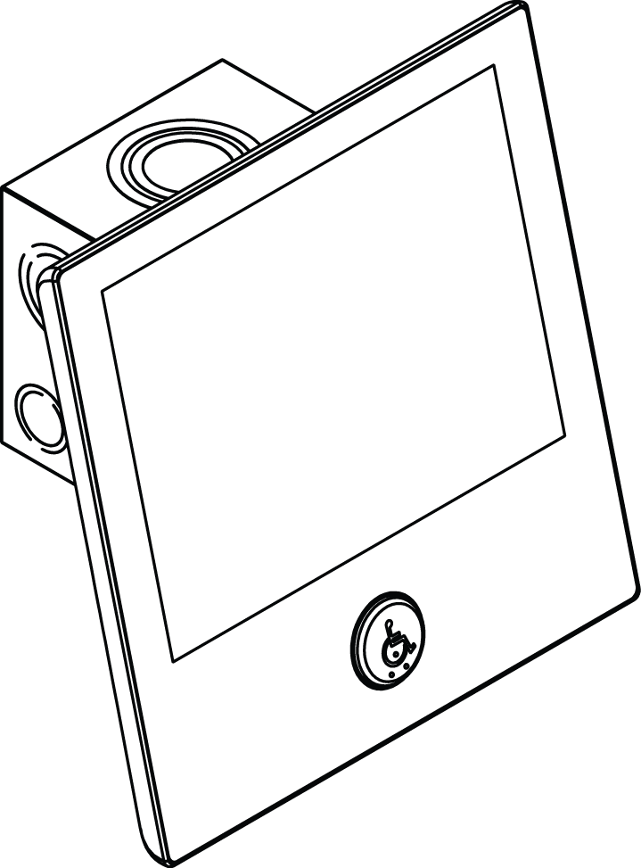 | 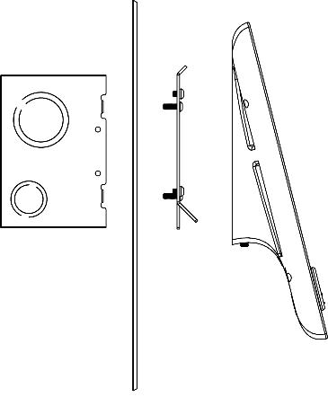  C  D  B  A  Optional Wall/Back Plate | A: Back Box (included, 1 per fixture)  (4 11/16” W x 4 11/16” H x 3 1/4” D)  B: Optional Wall/Back Plate Qty  Color / Finish:  Stainless #4*  Stainless #8  Muntz #4  Muntz #8  Black  White  C: Mounting Bracket (included, 1 per fixture)  D: DID Fixture - Glass & Enclosure:  Black Qty  White** Qty
M12b 10” Surface Mount New Construction, With Card Reader California Compliant
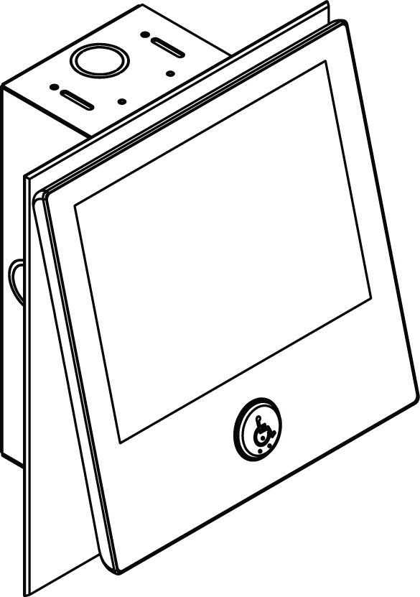 | 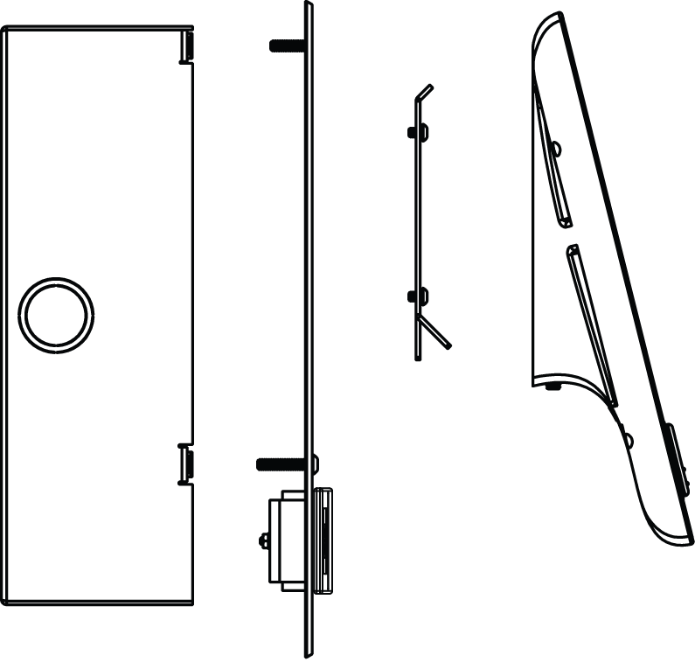  C  A  D  B | A: Back Box (included, 1 per fixture) ¹  ¹Size based on security card reader selected  B: Wall/Back Plate (included, 1 per fixture)  Wall/Back Plate Color / Finish:  Stainless #4*  Stainless #8  Muntz #4  Muntz #8  Black  White  C: Mounting Bracket (included, 1 per fixture)  D: DID Fixture - Glass & Enclosure:  Black Qty  White** Qty
M13 10” Vertical Mount, No Card Reader
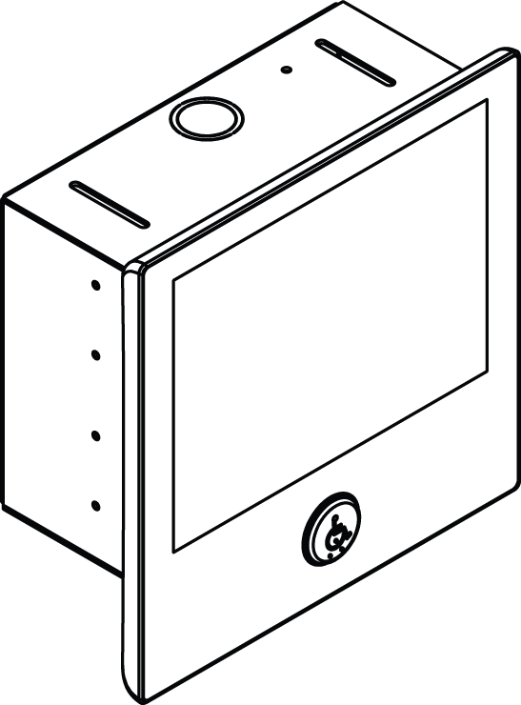 | 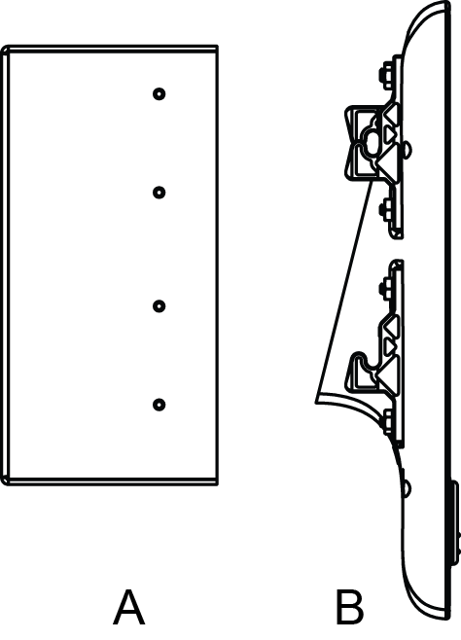 | A: Back Box (included, 1 per fixture)  (9” W x 7.12” H x 31/2” D)  B: DID Fixture - Glass & Enclosure:  Black Qty  White** Qty  Note: Integrated security card reader not available for this model.
*Included in base price
Destination Input Devices
**Black ADA button provided for both white and black fixtures

MCE Destination Input (DID) Fixtures (continued)
M14a 10” Applied Mount, Card Reader Optional
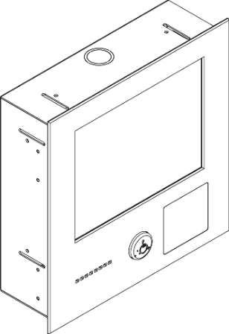 | 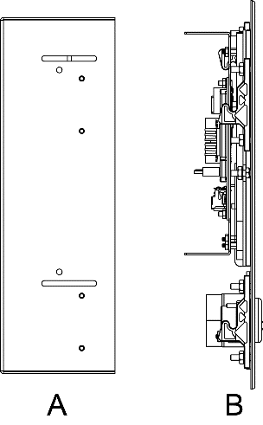 | A: Back Box (included, 1 per fixture)¹  ¹Size based on security card reader selected  B: 10” Applied Mount Fixture Qty  Faceplate & ADA Button** Color / Finish:  Stainless #4*  Stainless #8  Muntz #4  Muntz #8  Black  White**
M14b 10” Applied Mount QR Scanner
 | B  A  C | A: Back Box (included, 1 per fixture)  B: 10” Applied Mount Fixture Qty  Faceplate & ADA Button** Color / Finish:  Stainless #4*  Stainless #8  Muntz #4  Muntz #8  Black  White**  C: QR Scanner
M14c 10” Applied Mount with Step Scanner, Card Reader Optional [NYC Building Code, Chapter 11 Compliant]
 | A  B  C | A: Back Box¹ (included, 1 per fixture)  B: Mounting Bracket (included, 1 per fixture)  C: 10” Applied Mount Fixture¹ Qty  Fixture & ADA Button** Color / Finish:  Stainless #4*  Muntz #4  Black²  White²  ¹Size based on whether security card reader is selected.  ²Stainless #4 buttons provided for both white and black fixtures.
*Included in base price
**Black ADA button provided for both white and black fixtures
MCE Destination Input (DID) Fixtures (continued)
M15 10” Frameless, No Card Reader
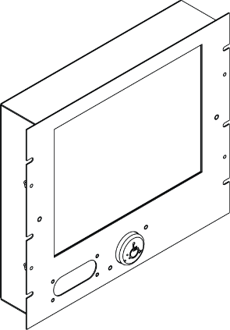 | 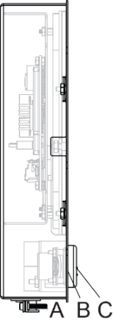 | A: 10” Frameless Fixture Qty  B: Speaker (included, 1 per fixture)  C: ADA Button (included, 1 per fixture)  Color / Finish:  Stainless #4*  Muntz #4  Customer supplied Faceplate.  Note: Integrated security card reader not available for this model.
M16 10” Pedestal, Against the Wall, Card Reader Optional (except 5127 Card Reader) California Compliant
A: Pedestal Stand (included, 1 per fixture)
(10” W x 47” H x 6-1/4” D)
Color/finish:
Stainless #4*
Black
White

B: Mounting Bracket (included, 1 per fixture):
C: DID Fixture - Glass & Enclosure:
Black Qty
White** Qty

*Included in base price
**Black ADA button provided for both white and black fixtures
MCE Destination Input (DID) Fixtures (continued)
M17 10” Pedestal, Standalone, Card Reader Optional (except 5127 Card Reader) California Compliant
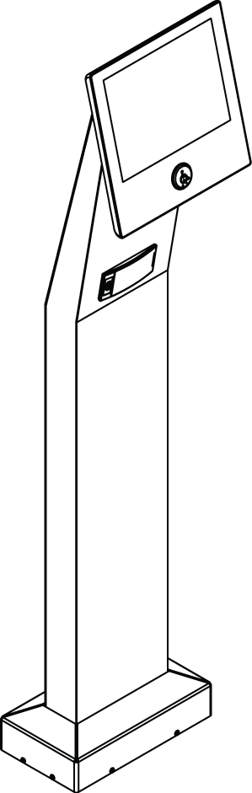 | 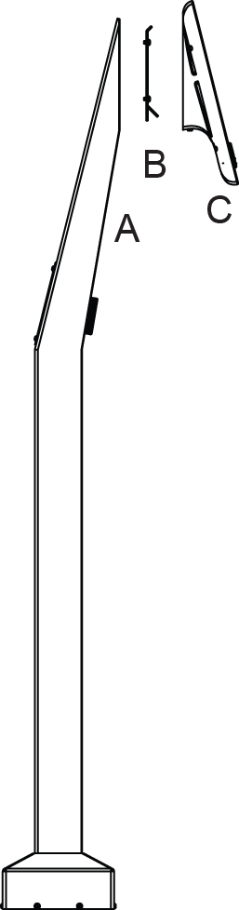 | A: Pedestal Stand (included, 1 per fixture)  (10-1/2” W x 47” H x 9-1/8” D)  Color/finish:  Stainless #4*  Black  White  B: Mounting Bracket (included, 1 per fixture):  C: DID Fixture - Glass & Enclosure:  Black Qty  White** Qty
M71a 7” Surface Mount Retrofit, Card Reader Optional (except 5127 Card Reader) California Compliant
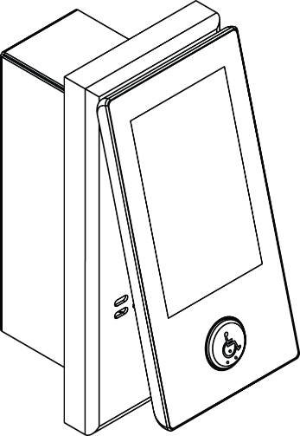 | 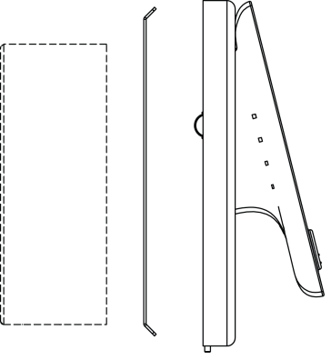  B  C  A  D  Existing Back Box shown. An optional Back Box can be ordered if required. | A: Optional Back Box Qty  (3” W x 9 ¼” H x 3 ½” D)  B: Mounting Bracket (included, 1 per fixture)  C: Fixture Base¹  Color / Finish:  Stainless #4*  Muntz #4  Black  White  ¹Size based on security card reader selected  D: DID Fixture - Glass & Enclosure:  Black Qty  White** Qty
M71b 7” Surface Mount New Construction, Card Reader Optional California Compliant
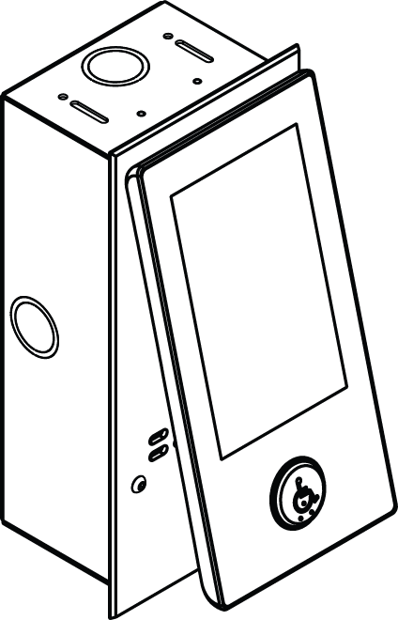 | 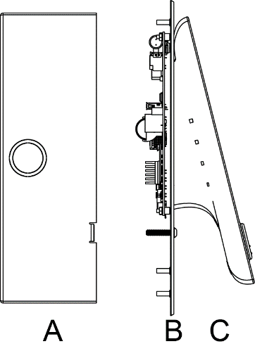  C  B  A | A: Back Box (included, 1 per fixture)¹  ¹Size based on security card reader selected  B: Wall/Back Plate (included, 1 per fixture):  Color / Finish:  Stainless #4*  Stainless #8  Muntz #4  Muntz #8  Black  White  C: DID Fixture - Glass & Enclosure:  Black Qty  White** Qty
*Included in base price
**Black ADA button provided for both white and black fixtures

MCE Destination Input (DID) Fixtures (continued)
M71c 7” Surface Mount New Construction, QR Scanner California Compliant
 | D  C  B  A | A: Back Box (included, 1 per fixture)  B: QR Scanner  C: Wall/Back Plate Color / Finish:  Stainless #4*  Stainless #8  Muntz #4  Muntz #8  Black  White**  D: DID Fixture - Glass & Enclosure:  Black Qty  White** Qty
M72a 7” Applied Mount, Card Reader Optional
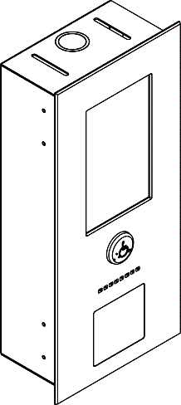 | 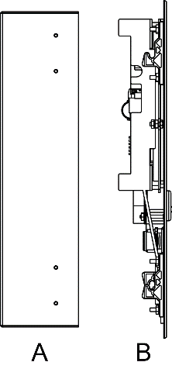 | A: Back Box (included, 1 per fixture)¹  (6.2” W x 12 ¾” H x 3 ½” D)  ¹Size based on card reader selected.  B: DID Fixture Qty  Faceplate & ADA Button** Color / Finish:  Stainless #4*  Stainless #8  Muntz #4  Muntz #8  Black  White**
M72b 7” Applied Mount, QR Scanner
 | A  C  B | A: Back Box (included, 1 per fixture)  B: 7” Applied Mount Fixture Qty  Faceplate & ADA Button** Color / Finish:  Stainless #4*  Stainless #8  Muntz #4  Muntz #8  Black  White**  C: QR Scanner

*Included in base price
**Black ADA button provided for both white and black fixtures
*Included in base price
**Black ADA button provided for both white and black fixtures
MCE Destination Input (DID) Fixtures (continued)
M72c 7” Applied Mount with Step Scanner, Card Reader Optional [NYC Building Code, Chapter 11 Compliant]
 | C  B  A | A: Back Box (included, 1 per fixture)¹  B: Mounting Bracket (included, 1 per fixture)  C: 7” Applied Mount Fixture¹ Qty  Fixture & ADA Button** Color / Finish:  Stainless #4*  Muntz #4  Black²  White²  ¹Size based on whether security card reader is selected.  ²Stainless #4 buttons provided for both white and black fixtures.
M73 7” Frameless, No Card Reader
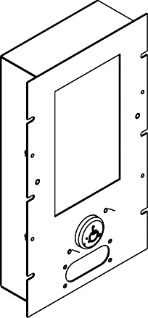 | 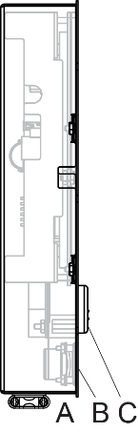 | A: DID Fixture Qty  B: Speaker (included, 1 per fixture)  C: ADA Button (included, 1 per fixture)  Color / Finish:  Stainless #4*  Muntz #4  Customer supplied Faceplate.  Note: Integrated security card reader not available for this model.
*Included in base price
**Black ADA button provided for both white and black fixtures
Destination Input Devices

CE Destination Input Devices
Two different touch screen sizes and a keypad are available. Display is 256 colors, single language. All can be mounted “Applied” (flat bezel with equipment mounted to the wall) or “Surface Mount” (equipment contained within the fixture metal work).
CE Destination Input (DID) Fixtures
C11 CE 10” Touch Screen, Surface Mount, Card Reader Optional
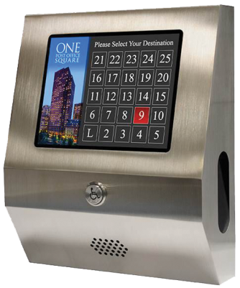 | 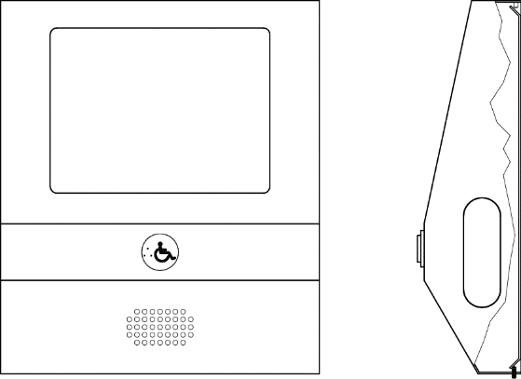 | Qty :  Mounting Plate (included, 1 per fixture)  Enclosure:12” W x 14” H x 3 5/8” D  Color / Finish:  Stainless #4*  Muntz #4  Custom (details required)  Security:  Fill Plate Smoked Plate
C12 CE 10” Touch Screen, Applied Mount, Card Reader Optional
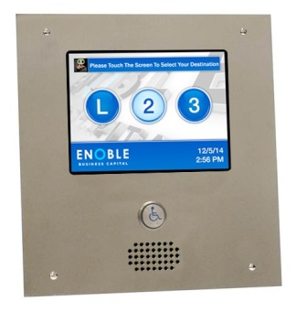 | 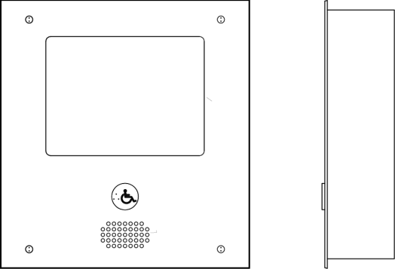 | Qty :  Back Box: 12” W x 13” H x 3 ½” D  Cutout required: 12 1/4” W x 13 1/4” H  Faceplate: 13” W x 14” H  Color / Finish:  Stainless #4*  Muntz #4  Custom (details required)
C13 CE 10” Frameless
Customer Supplied Enclosure |  | Qty  Speaker Qty  USB programming extension cable  Qty
C71 CE 7” Touch Screen, Surface Mount, Card Reader Optional
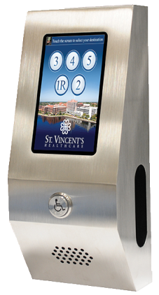 | 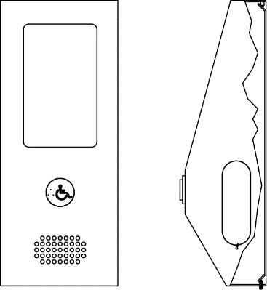 | Qty :  Mounting Plate: (included, 1 per fixture)  Enclosure: 5 3/4” W x 14” H x 4” D  Color / Finish:  Stainless #4*  Muntz #4  Custom (details required)  Security:  Fill Plate Smoked Plate
*Included in base price
Destination Input Devices

CE Destination Input (DID) Fixtures (continued)
C72 CE 7” Touch Screen, Applied Mount, Card Reader Optional
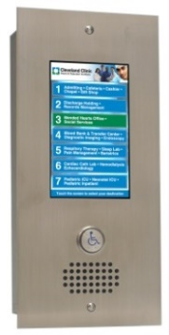 | 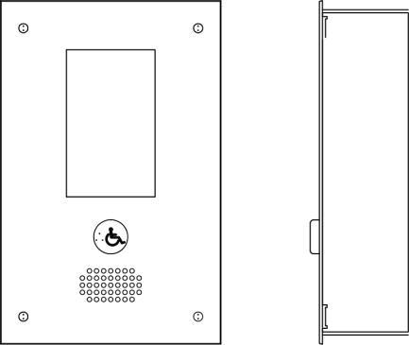 | Qty :  Back Box: 8” W x 13” H x 3 ½” D  Cutout required: 8 ¼” W x 13 ¼” H  Faceplate: 9” W x 14” H  Color / Finish:  Stainless #4*  Muntz #4  Custom (details required)
C73 CE 7” Frameless
Customer Supplied Enclosure | 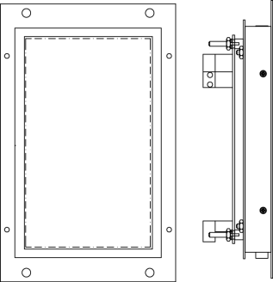 | Qty  Speaker Qty  USB programming Qty  extension cable
*Included in base price
Destination Input Devices
Turnstile Fixtures
T1 7” Turnstile (Card Reader not included)
Customer Supplied Enclosure |  | Qty  Speaker Qty  USB programming Qty  extension cable
T2 4.3” Turnstile (Card Reader not included)
Customer Supplied Enclosure | 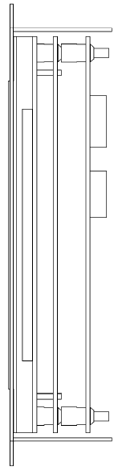 | Qty  Speaker Qty  USB programming Qty  extension cable

CE Destination Input (DID) Fixtures (continued)
K1 CE Keypad, Flat Surface Mount
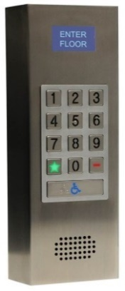 | 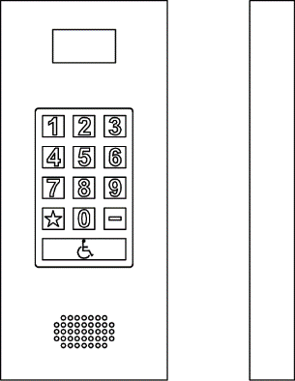 | Qty  Mounting Plate: (included, 1 per fixture)  Enclosure: 7” W x 16” H x 1 7/8” D  Color / Finish:  Stainless #4*  Muntz #4  Custom (details required)
K2 CE Keypad, Angled Surface Mount
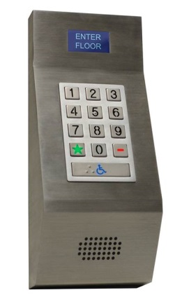 | 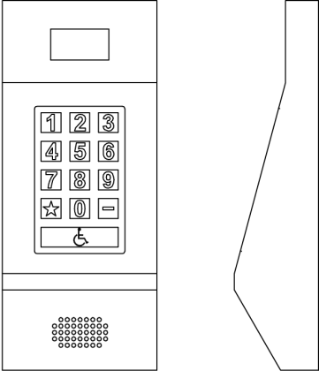 | Qty  Mounting Plate: (included, 1 per fixture)  Enclosure: 7” W x 16.75” H x 4” D  Color / Finish:  Stainless #4*  Muntz #4  Custom (details required)
Dimensions are intended for layout approximation only. Construction drawings are provided with equipment. *Included in base price
Destination Input Devices

Per-Car Hall Fixtures
Destination Input Devices
Per-Car Hall Fixtures identify the car, display the floors it is traveling to, and provide an identifying tone or message. We provide four options: a 5.7-inch LCD “combo” fixture with an 8-ohm speaker.
LCD Destination/Car Annunciator/Messaging/Arrival PI
H1 5.7” LCD Destination, Car Annunciator, Messaging, Arrival PI
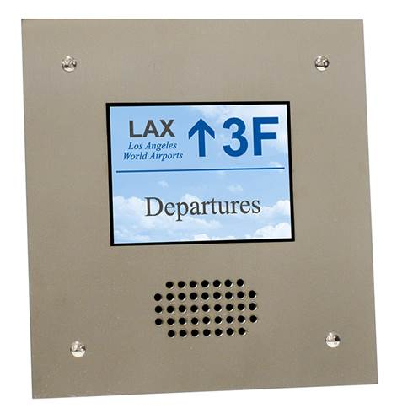 | 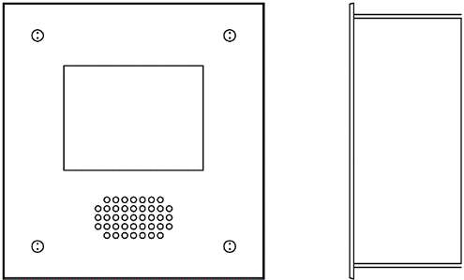 | Qty:  ADA tones & voice messages included.  8-ohm speaker provided.  Cutout required.7¾” W x 8 ¼” H  Back Box: 7 ½” W x 8” H x 3 ½” D  Faceplate: 8 ½” W x 9” H  Color / Finish:  Stainless #4*  Muntz #4  Custom (details required)  Note: Other sizes and options available. See your sales representative.

Annunciators
H2 mBox / mLBox Hall Fixture Surface Mount
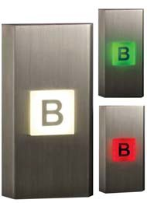 | 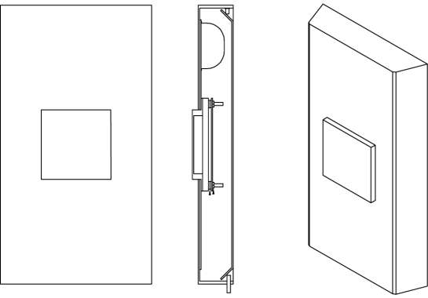 | Size: mBox mLBox Qty:  Floor gong  Voice board (option for voice messages)  Mounting Plate: (included, 1 per fixture)  Fixture: 6 ½” W x 12” H x 1 ½” D  Orientation: Mounting Style:  Vertical Applied  Horizontal Surface  Color / Finish:  Stainless #4*  Muntz #4  Custom (details required)
H3 mFlag Hall Fixture Surface mount
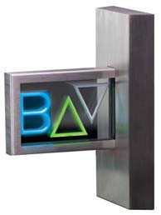 | 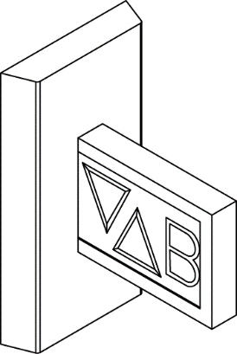 | Qty:  Surface mount  Includes floor gong  Voice board  Mounting Plate: (included, 1 per fixture)  Fixture: 6 ½” W x 12”H x 8 ½” D  Color / Finish:  Stainless #4*  Muntz #4  Custom (details required)
*Included in base price

In-Car Fixtures
Destination Input Devices
In-Car fixtures include a 4.3-inch LCD destination/arrival display or a vertical destination indicator. The LCD has an 8-ohm speaker output. It is highly recommended to have a pair of one of these fixture types per car along with a single speaker.
D1 4.3” LCD Display Applied Mount
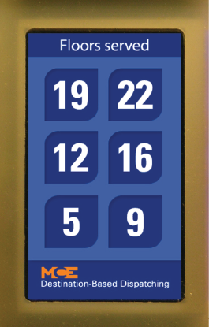 | 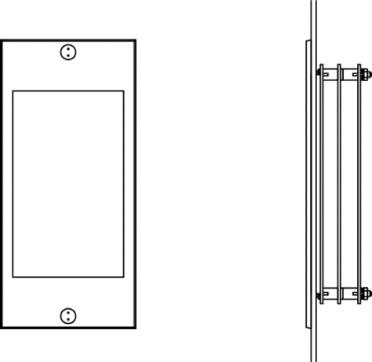 | Qty per car:  PI indication.  Passing chime output  8-ohm speaker output  Alternates PI/Destination floor display  Cutout required: 3.137” W x 6.062” H  Faceplate: 3 7/8” W x 7 1/2” H  Color / Finish:  Stainless #4*  Muntz #4  Custom (details required)
D2 4.3” LCD Display Applied Mount with Speaker
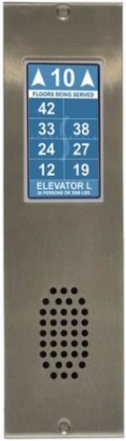 | 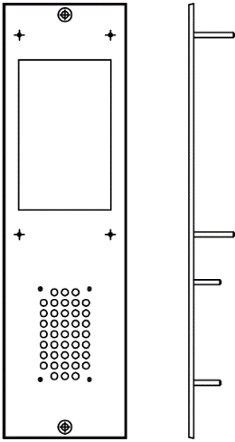 | Qty per car:  PI indication.  Passing chime output  8-ohm speaker output  Alternates PI/Destination floor display  Cutout required: 3.137” W x 6.062” H  Faceplate: 3 7/8” W x 12 1/2” H  Color / Finish:  Stainless #4*  Muntz #4  Custom (details required)
D5 / D6 Door Jamb Vertical Destination Indicator Applied Mount
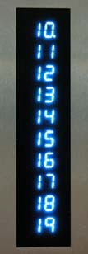 | 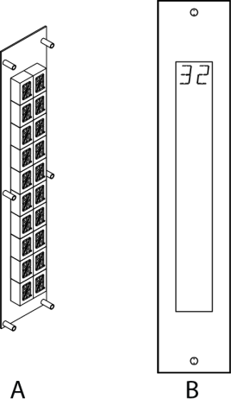 | Qty per car:  Scrolling if display length exceeded  Trailing dot indicates next floor  A: ½” Display Fixture: 3” W x 10” H*  1” Display Fixture: 3.25” W x 17” H  Display characters color:  Blue Green Red  B: Faceplates for:  ½” Display Fixture: 2 ¾” W x 10 ¼ H*  1” Display Fixture: 3 ¼” W x 17” H  Color / Finish:  Stainless #4*  Muntz #4  Custom (details required)
*Included in base price

