|  |  |  |  |  |  |
| --- | --- | --- | --- | --- | --- |
| In order to better serve you and meet your schedule, this form must be completed and signed. Timely delivery and trouble-free installation begin with these data forms. Accurate, complete information is essential. Non-response to a question will be defined as meaning that the item does not apply. **Note:** For any feature, accessory, or provision **NOT** listed, Element Series will not be able to meet the requirements of your application. Please contact your MCE Sales Account Manager for an alternate product price quotation. | | | | | |
| Date: | | Number of cars: | | | |
| Job Name: (26 Chars per line) | | | | | |
| Job Location (city and state): | | | | | |
| Contract Date: | | | | | |
| Project Type: New constructionModernization | | | | | |
| Customer Job #: | | PO#: | | | |
| Delivery Schedule | | | | | |
| Control | Delivery Date | | | | |
| Car “” |  | | | | |
| Car “” |  | | | | |
| Shipping Information | | | | | |
| Contact: | | | | | |
| Phone: | | | Fax: | | |
| Company name and address: | | | | | |
|  | | | | | |
|  | | | |  |  |
| City | | | | State | Zip Code |
| Shipping Requirement:Advanced Notice:  24 hours  48 hours Truck w/ Lift Gate:  Yes  No | | | | | |
| **Contractor Information** ( Check if same as above) | | | | | |
| Contact: | | | | | |
| Phone: | | | Fax: | | |
| Email: | | | | | |
| Company name and address: | | | | | |
|  | | | | | |
|  | | | |  |  |
| City | | | | State | Zip Code |

|  |
| --- |
| **Per state tax laws, it is critical that MCE receive exemption or resale certificates prior to the material being shipped and billed. If the job is a tax-exempt job, send the exemption certificate with this form. If you are a resale customer and have a resale certificate, please make sure that the MCE accounting department has a copy on file.** |

|  |  |
| --- | --- |
| Contact: | |
| Phone: | Fax: |
| Cell: | |
| Email: | |
| Company name: | |
| Signature: | |

|  |  |  |
| --- | --- | --- |
| Elevator Safety Code Compliance Accurate information is essential. | | |
| **North American Compliance:** U.S. Canada | | |
| **ASME A17.1/B44 Edition:** 2019  2016 2013 2010 2007 2004 2000 | | |
| **Addenda/Supplements:**  (None for A17.1-2010 and later) | | 2008(a) 2005(a) 2002(a)  2009(b) 2005(S) 2003(b) |
| ASME A17.1-1996 Addenda: 1997(a) 1998(b) | | |
| **Additional state or local code compliance** | | |
| Chicago Fire Code (select one):  Current **OR**  2001 | | |
| Denver | Pressurized hoistway | |
| Maryland | | |
| Massachusetts (2004) | | |
| Michigan (**NOTE**: Detroit **not** supported.) | | |
| Nebraska | | |
| New York City | | |
| Washington State | Seattle | |

|  |
| --- |
| **Selective Collective** (Supports single riser installation only) |
| **Simplex  Duplex\*\*\*** |

|  |  |  |  |  |  |  |  |  |  |  |  |  |  |  |  |  |  |  |  |  |  |  |  |  |  |  |  |  |  |  |  |  |  |  |  |  |  |  |  |  |  |  |  |  |  |  |  |  |  |  |  |  |  |  |  |  |  |  |  |  |  |  |  |  |  |  |  |  |  |  |  |  |  |  |  |  |  |  |  |  |  |  |  |  |  |  |  |  |  |  |  |  |  |  |  |  |  |  |  |  |  |  |  |  |  |  |  |  |  |  |  |  |  |  |  |  |  |  |  |  |  |  |  |  |  |  |  |  |  |  |  |  |  |  |  |  |  |  |  |  |  |  |  |  |  |  |  |  |  |  |  |  |  |  |  |  |  |  |  |  |  |  |  |  |  |  |  |  |  |  |  |  |  |  |  |  |  |  |  |  |  |  |  |  |  |  |  |  |  |  |  |  |  |  |  |  |  |  |  |  |  |  |  |  |  |  |  |  |  |  |  |  |  |  |  |  |  |  |  |  |  |  |  |  |  |  |  |  |  |  |  |  |  |  |  |  |  |  |  |  |  |  |  |  |  |  |  |  |  |  |  |  |  |  |  |  |  |  |  |  |  |  |  |  |  |  |  |  |  |  |  |  |  |  |  |  |  |  |  |  |  |  |  |  |  |  |  |  |  |  |  |  |  |  |  |  |  |  |  |  |  |  |  |  |  |  |  |  |  |  |  |  |  |  |  |  |  |  |  |  |  |  |  |  |  |  |  |  |  |  |  |  |  |  |  |  |  |  |  |  |  |  |  |  |  |  |  |  |  |  |  |  |  |  |  |  |  |  |  |  |  |  |  |  |  |  |  |  |  |  |  |  |  |  |  |  |  |  |  |  |  |  |  |  |  |  |  |  |  |  |  |  |  |  |  |  |  |  |  |  |  |  |  |  |  |  |  |  |  |  |  |  |  |  |  |  |  |  |  |  |  |  |  |
| --- | --- | --- | --- | --- | --- | --- | --- | --- | --- | --- | --- | --- | --- | --- | --- | --- | --- | --- | --- | --- | --- | --- | --- | --- | --- | --- | --- | --- | --- | --- | --- | --- | --- | --- | --- | --- | --- | --- | --- | --- | --- | --- | --- | --- | --- | --- | --- | --- | --- | --- | --- | --- | --- | --- | --- | --- | --- | --- | --- | --- | --- | --- | --- | --- | --- | --- | --- | --- | --- | --- | --- | --- | --- | --- | --- | --- | --- | --- | --- | --- | --- | --- | --- | --- | --- | --- | --- | --- | --- | --- | --- | --- | --- | --- | --- | --- | --- | --- | --- | --- | --- | --- | --- | --- | --- | --- | --- | --- | --- | --- | --- | --- | --- | --- | --- | --- | --- | --- | --- | --- | --- | --- | --- | --- | --- | --- | --- | --- | --- | --- | --- | --- | --- | --- | --- | --- | --- | --- | --- | --- | --- | --- | --- | --- | --- | --- | --- | --- | --- | --- | --- | --- | --- | --- | --- | --- | --- | --- | --- | --- | --- | --- | --- | --- | --- | --- | --- | --- | --- | --- | --- | --- | --- | --- | --- | --- | --- | --- | --- | --- | --- | --- | --- | --- | --- | --- | --- | --- | --- | --- | --- | --- | --- | --- | --- | --- | --- | --- | --- | --- | --- | --- | --- | --- | --- | --- | --- | --- | --- | --- | --- | --- | --- | --- | --- | --- | --- | --- | --- | --- | --- | --- | --- | --- | --- | --- | --- | --- | --- | --- | --- | --- | --- | --- | --- | --- | --- | --- | --- | --- | --- | --- | --- | --- | --- | --- | --- | --- | --- | --- | --- | --- | --- | --- | --- | --- | --- | --- | --- | --- | --- | --- | --- | --- | --- | --- | --- | --- | --- | --- | --- | --- | --- | --- | --- | --- | --- | --- | --- | --- | --- | --- | --- | --- | --- | --- | --- | --- | --- | --- | --- | --- | --- | --- | --- | --- | --- | --- | --- | --- | --- | --- | --- | --- | --- | --- | --- | --- | --- | --- | --- | --- | --- | --- | --- | --- | --- | --- | --- | --- | --- | --- | --- | --- | --- | --- | --- | --- | --- | --- | --- | --- | --- | --- | --- | --- | --- | --- | --- | --- | --- | --- | --- | --- | --- | --- | --- | --- | --- | --- | --- | --- | --- | --- | --- | --- | --- | --- | --- | --- | --- | --- | --- | --- | --- | --- | --- | --- | --- | --- | --- | --- | --- | --- | --- | --- | --- | --- | --- | --- | --- | --- | --- | --- | --- | --- | --- | --- | --- | --- | --- | --- | --- | --- | --- | --- | --- | --- | --- | --- | --- | --- | --- | --- | --- | --- | --- | --- | --- | --- | --- | --- | --- | --- | --- | --- | --- | --- | --- | --- | --- | --- | --- |
| |  |  |  |  |  |  |  |  |  |  |  |  |  |  |  |  |  |  |  |  |  |  |  |  |  |  | | --- | --- | --- | --- | --- | --- | --- | --- | --- | --- | --- | --- | --- | --- | --- | --- | --- | --- | --- | --- | --- | --- | --- | --- | --- | --- | | **Hoistway Configuration, Speed & Capacity** | | | | | | | | | | | | | | | | | | | | | | | | | | | Floor  Label  **\*** | Landing  # | | Floor  Height | | | | Car | | Car | | Lobby Floor | Parking Floor | | | | Fire Service Recall Landing | | | Car Call Security  Key Floor Lockout  Card Reader Dry Contact.  (24V Contact Rating)  **\*\*** | | | Pit Flood Operation | | | EMT Service | |  |  | |  | | | |  | |  | |  | Main | | Alternate | | Main | | Alternate |  | | |  | | |  | |  |  | | |  | |  | |  | |  | | |  | |  | |  | | |  |  | |  |  | | |  | | | |  | | --- | | *O.H.* | | *5-6* | | *4-5* | | *3-4* | | *2-3* | | *1-2* | | *Pit* | | | | | **Select floors served:** | | | |  | | | | | | | | | | | | | | | |  | 6 | |  | | | |  | |  | |  |  | |  | |  | |  |  | | |  | | |  | |  | 5 | |  | | | |  | |  | |  |  | |  | |  | |  |  | | |  | | |  | |  | 4 | |  | | | |  | |  | |  |  | |  | |  | |  |  | | |  | | |  | |  | 3 | |  | | | |  | |  | |  |  | |  | |  | |  |  | | |  | | |  | |  | 2 | |  | | | |  | |  | |  |  | |  | |  | |  |  | | |  | | |  | |  | 1 | |  | | | |  | |  | |  |  | |  | |  | |  |  | | |  | | |  | |  | | |  | | | | If | | | | | | | | | | | | | | | | | | | | Capacity | | lbs. | | | kg | |  | |  | |  | If no parking floor, car stays at last call answered.  Park with Doors Open.  Doors stay open without demand.  Egress floor ___ | | | | Hoistway Sensor(s)  Above lowest landing of recall  At or below lowest landing of recall  None  At or below designated level | | | Key Floor Lockout Switch Location  COP  Lobby  Card Reader Override Switch Location  COP  Lobby  None  Independent Service Override | | | Please indicate lowest landing car can serve in an event of a flood. | | | Please indicate main EMT return floor. | | Up Speed | | fpm | | | m/s | |  | |  | |  |  | | | |  | | |  | | |  | | |  | | Down Speed: | | fpm | | | m/s | |  | |  | |  |  | | | |  | | |  | | |  | | |  | | Total Car Travel: | | ft | | | m | |  | |  | |  |  | | | |  | | |  | | |  | | |  |  * Floor Label note: For CE or E-Motive driver board, floor label should not be more characters than the number of digital PI displaycharacters (LED Characters) **\*\*** Card Reader Dry Contact note: If selected, all floors will be secured by default. However, this can be changed in the controller  configuration menu.  **\*\*\*** Only single machine room and single hoistway are supported for duplex applications. |

|  |
| --- |
| **Line Voltage** |
| **3-Phase AC Line Voltage** (actual measured line voltage)  Symmetrical  Grounded Leg Delta  (ISO transformer required)  Choose closest selection below: |
| 208  220  240  440  460  480  575  600 |
| 60 Hz (standard in U.S.)  50 Hz |
| Available Fault Current from AC Feed (kA):  Standard Controller SCCR (Short Circuit Current Rating):   * Up to 50 hp: 5kA * 51-200 hp: 10kA   If the available fault current exceeds these standard values, please notify MCE for a quote. |

|  |
| --- |
| Hydraulic Data **IMPORTANT:** Only single motor operation and standard 4-coil, 120 VAC, valves are supported by this product. |
| **Solid State Motor Starter**  Brand:  Siemens  Sprecher + Schuh |
| **Pump Motor**  Motor brand: HP: |
| Voltage:  FLA: |
| Number of Leads: 36912  Starts per hour:  80  120 |
| **Valve Type** (120 VAC / 4 coil valve)  Brand  EECO  Maxton  Blain  TKE/Dover  Model: |
| **Hydraulic Features**  Battery Rescue (MCE HAPS)  Life Jacket Interface  Low Oil Switch  Contact Status:  N/O N/C  Oil Tank Temperature Shutdown Switch  (required for A17.1-2010/B44-10 and later)  Pressure Switch Interface  (required when top of cylinder is above top of storage tank)  Viscosity Control  Resynchronous Circuit for Telescopic or Dual Pistons |

|  |  |
| --- | --- |
| **Operating Features** | |
| **Earthquake Service**  Seismic Switch  By MCE  By Customer | |
| **Emergency Power Generator**  **Simplex** Resume operation after recovering to closest floor.  **Duplex** Sequentially lowers both cars to lobby. 3-position Emergency power/standby switch (Auto / Car A / Car B) will select which elevator to run. | |
| **Fire Service Operation** (Fire Operation Provided as Standard)  Additional Phase 1 Recall Switch  Nudging during Fire Recall | |
| **Inspection/Access Requirements**  Car Top Inspection Station by MCE (NEMA 1 only)  In-Car Inspection (2-position switch)  With Up/Down Buttons  Hoistway Access (2-position switch on COP required)  Top  Bottom | |
| **Load Weigher**  Discrete Load Weigher Interface | |
| **Recall Switch** | |
| **Car to Lobby Switch**  Recall Landing:       Floor Label:  Park with doors:  Open  Closed  Location of Switch:  Car  Hall | |
| **Car to Floor Switch**  Recall Landing:       Floor Label:  Park with doors:  Open  Closed  Location of Switch:  Car  Hall | |
| **Car Shut Down Switch**  Recall Landing:       Floor Label:  Park with doors:  Open  Closed  Location of Switch:  Car  Hall | |
| **Hoistway**  (**IMPORTANT:** Only **NEMA 1** hoistway supported on this product.) |
| **Landing System**  **Distance Feedback**  LS-EDGE  **Non-distance feedback**  LS-QUTE-24  Customer Supplied  **Tape Length Required** (ft):  **Tape Type**  Steel (Standard)  Stainless Steel |
| **EECO Limit Switch**  (Note: Mechanical limits are not required with LS-EDGE landing system) |
| **Element Traveling Cable (see page 5 for details)**  (Hang length maximum 200 ft.)  Cable Length Required (ft):  Cable Accessories  Kellem Grips |

|  |  |  |  |
| --- | --- | --- | --- |
| Automatic Passenger Style Doors **IMPORTANT:** Only fully automatic, horizontally-sliding, passenger-style doors are supported on this product. | | | |
| **Built-in:** Door operator interface is built in. The controller can interface with the door operator directly.  **IPC Universal Interface:** Interface with existing operator to open loop. Uses IPC Universal Interface Board.  **SmarTraq Upgrade Kit**: Upgrades existing door operator to closed loop. Comes with drive interface and motor. | | | |
| **Door Operator** | |  |  |
| **Manufacturer** | **Model** |  | **Interface** |
| **Armor** | C4 |  | SmarTraq Upgrade Kit |
| **ECI** | 895 |  | Built-In |
| 1000 |  | Built-In |
| 2000 |  | Built-In |
| VFE2500 (220V only) |  | Built-In |
| **GAL** | MOD (220V only) |  | Built-In |
| MODHFL (220V only) |  | Built-In |
| MODP |  | IPC Universal Interface |
|  | SmarTraq Upgrade Kit |
| MOVFR (220V only) |  | Built-In |
| **Haughton** | T |  | IPC Universal Interface |
|  | SmarTraq Upgrade Kit |
| T1 |  | IPC Universal Interface |
|  | SmarTraq Upgrade Kit |
| TH |  | IPC Universal Interface |
|  | SmarTraq Upgrade Kit |
| **MCE** | Profile |  | Built-In |
| SmarTraq |  | Built-In |
| **Montgomery** | MAC PMSSC |  | Built-In |
|  | SmarTraq Upgrade Kit |
| Old-Style MAC |  | IPC Universal Interface |
|  | SmarTraq Upgrade Kit |
| **Otis** | 7300 |  | IPC Universal Interface |
|  | SmarTraq Upgrade Kit |
| 7782 |  | IPC Universal Interface |
|  | SmarTraq Upgrade Kit |
| 6970A - Reactance |  | IPC Universal Interface |
|  | SmarTraq Upgrade Kit |
| 6970A - Resistance |  | IPC Universal Interface |
|  | SmarTraq Upgrade Kit |
| AT400* |  | Built-In |
| OVL (Gear Ratio 6:67.1) |  | IPC Universal Interface |
|  | SmarTraq Upgrade Kit |
| OVL (Gear Ratio 11:33.1) |  | IPC Universal Interface |
|  | SmarTraq Upgrade Kit |
| **TKE/Dover** | 052 |  | IPC Universal Interface |
| DC-62 |  | IPC Universal Interface |
|  | SmarTraq Upgrade Kit |
| DC-68 |  | IPC Universal Interface |
|  | SmarTraq Upgrade Kit |
| HD-70 |  | IPC Universal Interface |
|  | SmarTraq Upgrade Kit |
| HD-73 |  | IPC Universal Interface |
|  | SmarTraq Upgrade Kit |
| HD-85 |  | SmarTraq Upgrade Kit |
| HD-91 |  | IPC Universal Interface |
|  | SmarTraq Upgrade Kit |
| HD-98 |  | SmarTraq Upgrade Kit |
| HD-LM |  | Built-In |
| MKII |  | IPC Universal Interface |
| TypeD |  | IPC Universal Interface |
| **Westinghouse** | A |  | SmarTraq Upgrade Kit |
| AA |  | IPC Universal Interface |
| B |  | IPC Universal Interface |
|  | SmarTraq Upgrade Kit |
| BB |  | IPC Universal Interface |
| BB2 |  | IPC Universal Interface |
|  | SmarTraq Upgrade Kit |
| E |  | IPC Universal Interface |
|  | SmarTraq Upgrade Kit |
| E4A |  | IPC Universal Interface |
| EZ |  | SmarTraq Upgrade Kit |
| HY |  | IPC Universal Interface |
|  | SmarTraq Upgrade Kit |
| MG |  | IPC Universal Interface |
|  | SmarTraq Upgrade Kit |
| MS |  | IPC Universal Interface |

*Requires customer supplied DC Power Supply.

|  |
| --- |
| **Door Features**  Door Hold Operation (non-fire operation)  Switch Button (default hold time = 120 seconds)  Infrared detector unit/photo eye  Cut-out switch in COP  Nudging Output†  Buzzeronly (doors remain open)  Reduced closing torque & buzzer  Nudging with stuck photo eye  † Buzzers/Lights must be 24VDC |

|  |
| --- |
| **Fixtures** |
| **Auxiliary Car Station**  Discrete wiring to main COP board.  Provide additional serial COP board. |
| **Call Registration**  Serial Car Call (standard)  Serial Hall Call (standard) |
| **Lanterns & Gongs/Chimes**  Car Lanterns†  Discrete  Serial 3-wire  Hall Lanterns† (Only Serial 3-wire supported)  Passing Floor Gong†  Passing Floor Gong Enable (“S”) Button Interface  † Buzzers/Lights must be 24VDC |
| **Indicators**†  Call Registration Buzzer  Door Hold Light  Egress Floor Gong  In-Service Light  Security Light  † Buzzers/Lights must be 24VDC |
| **Serial Fixture Driver Format** (Built into CPU board in controller)  CE Electronics 3-Wire Micro Comm  E-Motive 3-Wire Driver |
| **Serial Fixture Pre-Wire**  Ship Serial Boards to fixture manufacture for pre-wire:  Contact Person:  Phone#: (   )     -  C.E. Electronics  EPCO  Dupar  Innovation Industries  Monitor  Mad  ERM  PTL  Elevator Contractor Office  Other          Which boards to be sent? COP Hall Station Node |
| **Voice annunciation**  MCE CE 3-wire driver board interface (built into controller)  Other: |

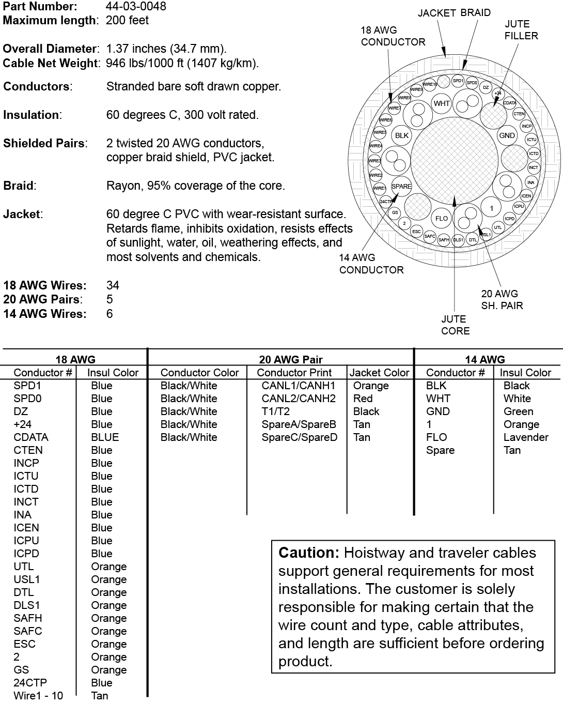

**Element Traveling Cable**